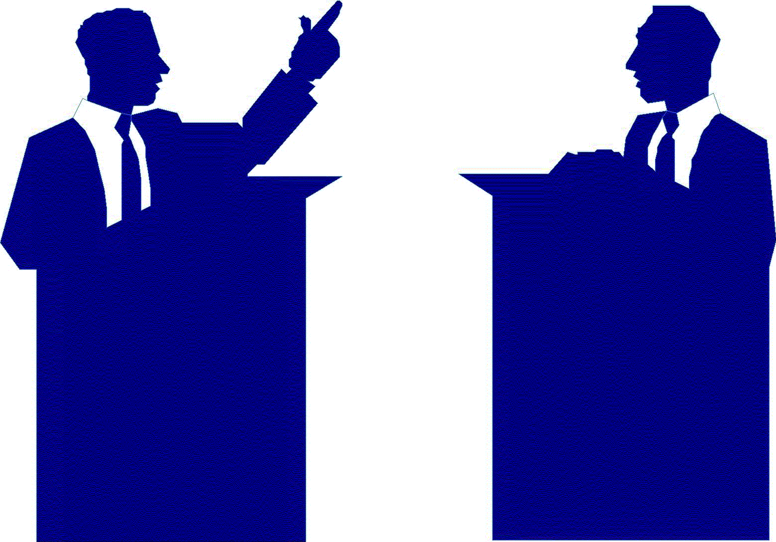

**All of these people participated in High School Forensics!**

Chris Colfer

**Malcolm X**

Roger Ebert

**President L. B. Johnson**

Janet Reno

**Justice Antonin Scalia**

Governor Freudenthal

**Brad Pitt**

David Cook

**Justice Sotomayor**

Jane Pauley

**David Bloom**

**Nelson Mandela**

Nancy Cartwright

**Kofi Annan**

Bruce Springsteen

**60% of US Congress**

Floyd Abrams

**James Earl Jones**

Brent Mintz

**Zac Efron**

Zach Quinto

**Ted Turner**

**Your Name Here**

Margaret Thatcher

**Oprah Winfrey**

Kelsey Grammer

**President Nixon**

Jared Padalecki

**Adam Sandler**

Tom Brokaw

**Weird Al Yankovic**

Colonel William Taylor

**Justice Stephen Breyer**

Patricia Neal

**Jon Lovitz**

**FAMOUS SPEECH/DEBATE STUDENTS**